WELCOME TO CS-521!!!

Tue - Thu, 6-7:30 p.m.

Lecture 9 (Dec 1, 2020)

Week 5:

Homework 5

Quiz 5

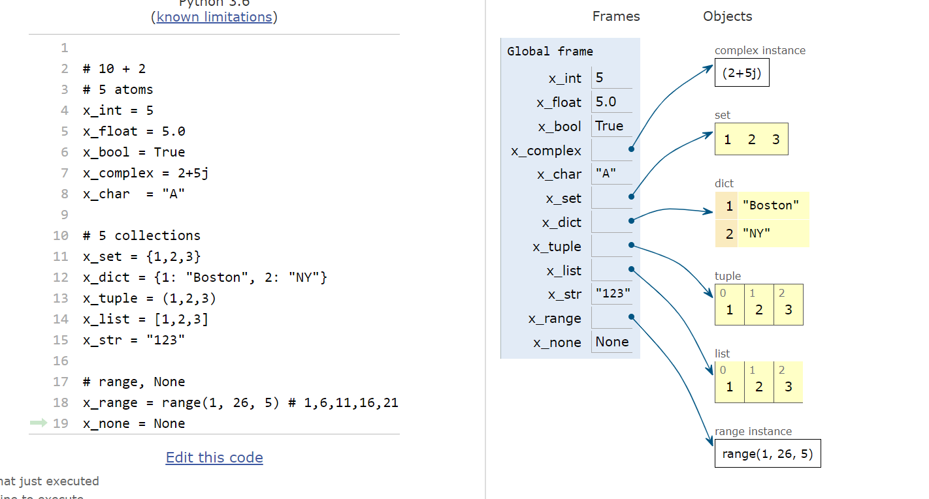

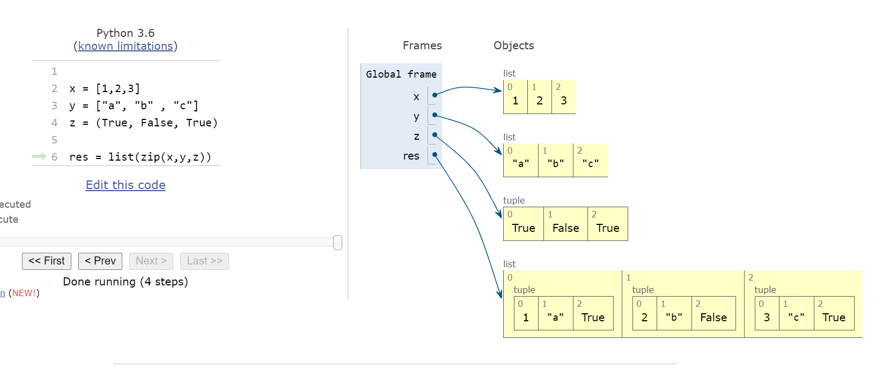

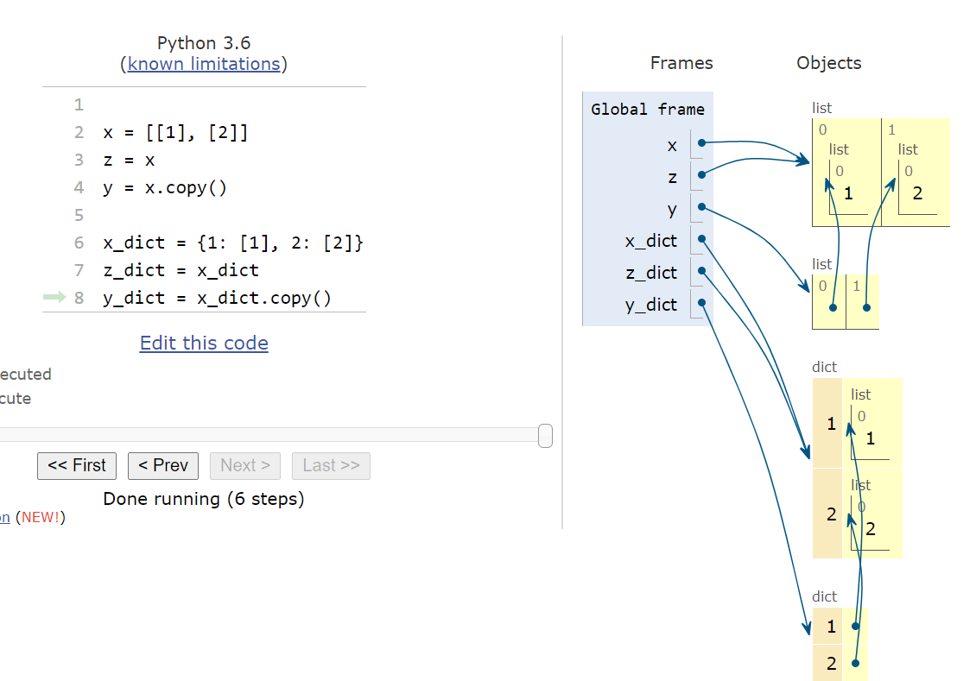

STAY HEALTHY AND WELL!!!!

Are there guidelines on which data type to use in a program for specific tasks?

There are algorithms that require an existence of a stack

example:

x = 2 + 2 \* 2 # compiler use stack to enforce precedence

EXCEPTIONS

events that prevent Python from completing its execution:

1. external to your program (hits ^C, you lose internet connection, ….) – interrupts
2. internal to your program (error on some inputs) – use illegal index, divide by 0, access a value from a dictionary using a key that does not exist ….

these are called exceptions

Does Python have a mechanism to handle this?

YES ---------------🡪 try/except construct

TYPICALLY the way to use try/except is the following:

try:

code

----

code

except Exception as e:

print(e) # prints Python message

deal with errors here

Can try/except be replaced by if/else? What is the difference between them?

yes you can The problem is that it is difficult to anticipate all possible error conditions

Therefore, in practice we use try/except

FUNCTIONS:

what is the difference between docstring and comment?

a function without an explicit return statement returns None

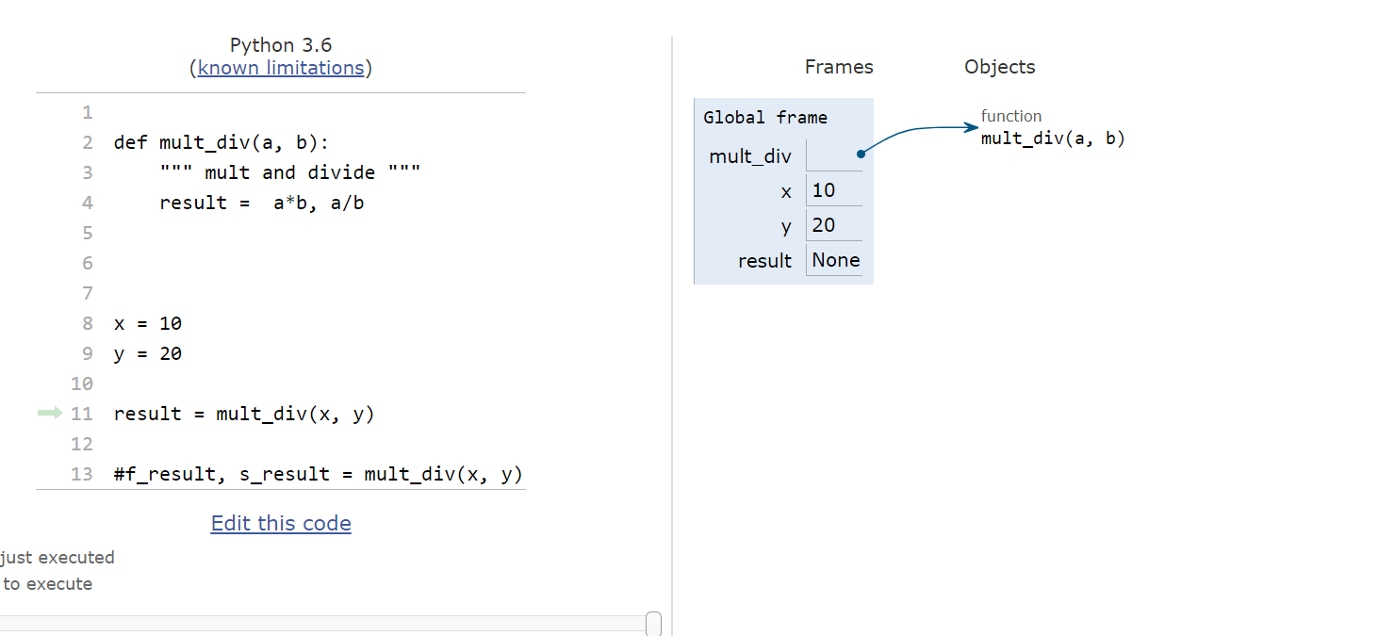

in Python, if a function has an explicit return statement, results are returned in a tuple

This means that a function in Python can return multiple results at once

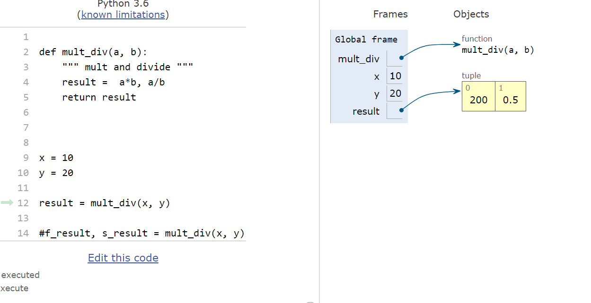

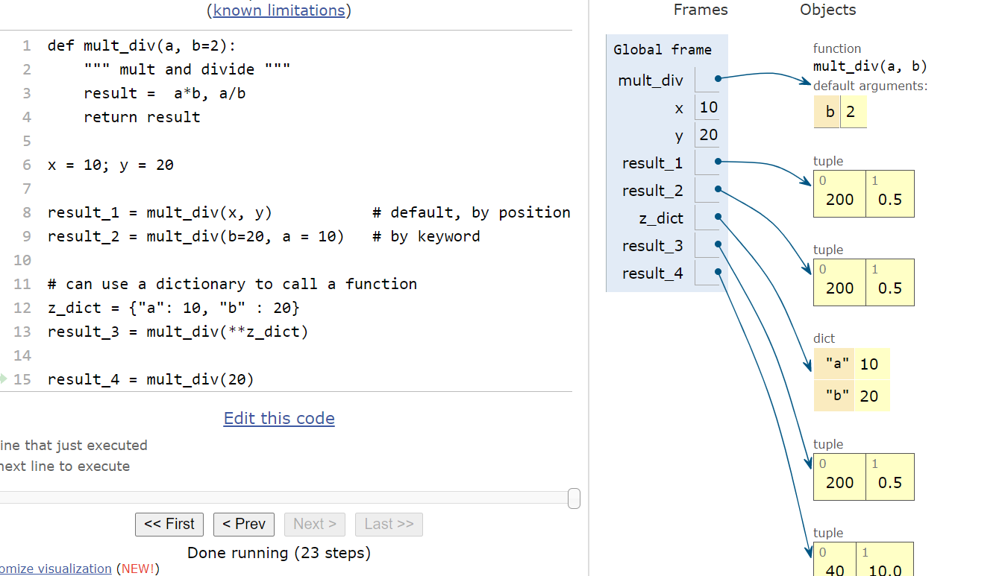

in python you can input your arguments in different ways (by position, keyword, dictionary)

The specification of input parameters is called a “signature”

In some languages (like Java) if two functions have the same name but different signatures, they are treated as two separate functions

NOT IN PYTHON: in Python a function is identified by name only!!!!!

Is there a way to input a variable number of arguments to a function?

YES. Python uses special syntax for this:

(single \*)

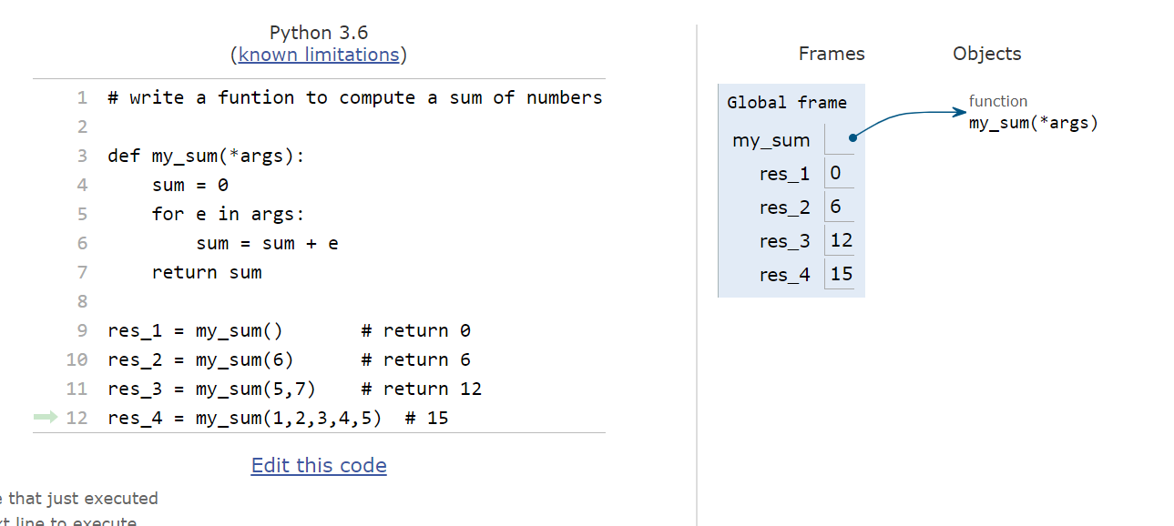

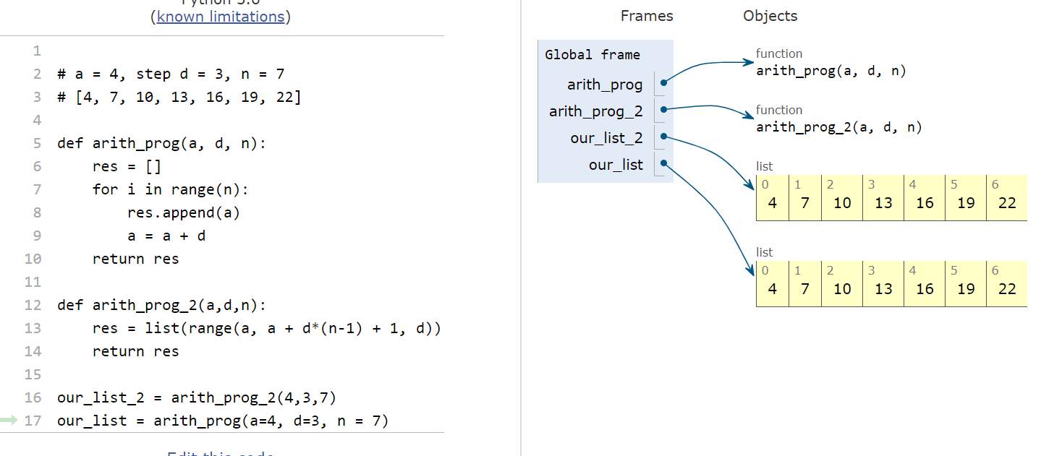

need to discuss:

* how does Python pass parameters (by reference or by value)
* recursive functions
* functional programming

STAY HEALTHY AND WELL